Bulletin 2
Nordic Championship F3J, Sweden 2009

On behalf of the Swedish Airsports Federation, Herrljunga modellflygklubb hereby invites the Nordic countries to the Nordic Championship F3J 2009. The competition will be held during the weekend 25 - 26. July 2009, at Herrljunga model airfield west of Herrljunga, (approx. 100 km north-east of Gothenburg).
Teams
Each country is invited to participate with three teams consisting of 3 senior-pilots and one junior pilot. If a team do not have a junior pilot, the fourth person can be a senior. In that case the three pilots that forms the senior team, must be pointed out before the competition starts. The teams will be ranked according to the "three pilots team", although the "working-groups" will be with four pilots.
Juniors will be ranked individually, although they fly in the same matrixes as the seniors. If wanted, the juniors from one country might choose to fly together in one team.
Rules
All competitors must possess a valid FAI Sporting License. International pilots must present valid third party insurance. The FAI class F3J rules will be used, except for launching of the model where F3B winch preferably will be used.

The field will be set up for F3B winches with 150m to the turnaround. It will in most lanes not be possible to run past the 150m mark because of the size of the field if teams choose to use pulley and running. The starting positions will alter beetween day 1 and day 2 and is drawn.
Jury
A jury, consisting of three -3- persons, will be elected at the TM-meeting, Friday 24 July 21:00
Languages
The languages used will be English and Swedish.
Meals & refreshments
Breakfast and Lunch will be served Saturday and Sunday, and Dinner will be served Saturday evening.
All these meals are included in the Entry fee for TM and pilots. Booking of these meals for helpers, at the entry form. There will be organised sales of refreshing drinks on the site.
Frequencies
Following frequencies are allowed in Sweden:
26.825-27.195 MHz (8 channels, nos. 87-98, 04-24)
30.270-30.350 MHz (9 channels, nos. 27-35)
35.000-35.270 MHz (28 channels, nos. 60-87)
40.665-40.745 MHz (9 channels, nos. 50-56A)
2.400-2.485GHz (Maximum power: 100mW eirp)
Please note that, according to the rules, each competitor must be able to operate two different frequencies, at least 20 kHz apart. (Not applicable for 2.4GHz).
Lodging
a) Toilets and power supply will be provided, at the flying field.

b) Hostels and Hotels :
Tourist information Herrljunga or www.herrljunga.se
Vårgårda & Tånga Hed

Preliminary schedule:
Friday 24.
Arrival and registration
The flying field is open for practice
21:00 TM-meeting
Saturday 25.
08:00 Breakfast
09:00 Briefing
09:15 Official rounds
Lunch
20:00 Dinner
Sunday 26.
08:00 Breakfast
09:00 Briefing
09:15 Official rounds
Lunch
14:00 Last start of a new round
4 finals
17:00 Prize ceremony, departure
Fees
Entry fee (TM and contestants only): SEK 750 (including all meals: Starting with breakfast Saturday morning to lunch at Sunday).
Entry fee Juniors: SEK 550 (including all meals: Starting with breakfast Saturday morning to lunch at Sunday)
Per extra person: All meals: Starting with breakfast Saturday morning to lunch at Sunday : SEK 300. Booking of these meals for helpers, at the entry form.

Protest: The fee for a protest will be 300 SEK.

Entry
Return the entry form before July 7.
No entries will be valid until the fees are received.

If any questions arise, don’t hesitate to contact us by E-mail or phone.
Good luck, we’ll see you there!
Updated information will be available at http:/www.modellsegelflyg.se
Tourist attractions (For flyers):
Ålleberg soaring/sailplane museum in Falköping.
Also the best slope for slope soaring in the middle of sweeden.
Located 40Km East of Herrljunga.
http://www.svs-se.org/museum

Tourist attraction (Family)
Skara Summerland (Sweden’s largest water land)
Located 65Km North-East of Herrljunga
http://www.sommarland.se/
How to find your way:

From South:
From Gothenburg take E20 to Vårgårda. At Stockholmsvägen turn right towards Herrljunga. In Herrljunga turn left toward Fölene and follow Bitternavägen for aprox. 1.3km. Agin turn Left toward Fölene, follow Vretavägen for 1.6km and you’ll se the club house (with the sign “HMFK”) on left hand.

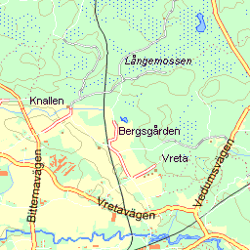
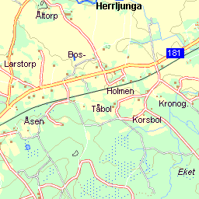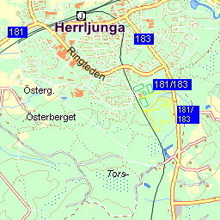

Coordinates: Lat/Long: N 58º 5' 14.43" E 12º 59' 11.37"

